ITS Dental College is proud to run 7 satellite centers that are all dedicated to provide oral health care solutions specifically for the people at the lower end of socio economic strata. The centres also work towiden the clinical opportunities and broaden the perspective for students pursuing dentistry. Through tailor made educational awareness programmes, these centers inculcate sound oral health care and practises among the rural population. The treatments and services given in the centresare not only of the highest quality standards but are also cost effective when compared to private clinics. Moreover, in case of any advanced dental treatment, transport is providedto and fro on a regular basis for the patients to ITS-CDSR.

SIWAL KHAS SATELLITE CENTER
(TOTAL PATIENTS TREATED TILL DATE – 1,653)
SiwalKhas satellite center (started - 2014) is 23 km from ITS Dental College, situated near the village of NanglaKumbh, SiwalKhas via Jani Meerut on Kanwad Road. There are more than 30 villages in and around the satellite center which is well equipped to cater to their needs. The satellite center has a well qualified dentist posted there and provides high quality dental treatment The timings of the satellite center are from 9am to 2pm and 3.30 pm to 5.30 pm in the evening. All kind of dental treatment is done in the satellite center and the charges are nominal.
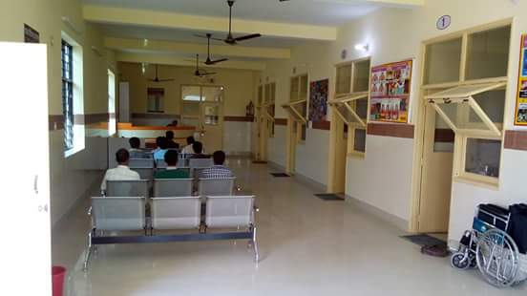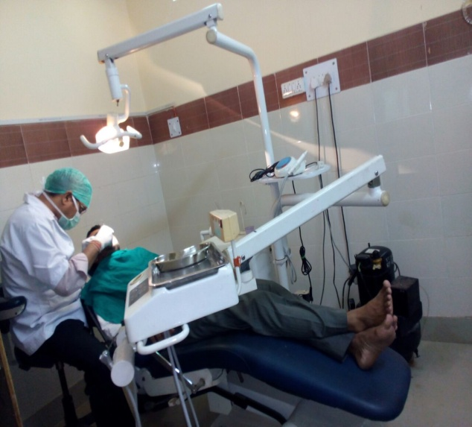

SANJAY NAGAR SATELLITE CENTER
(TOTAL PATIENTS TREATED TILL DATE – 57,273)
Sanjay Nagar satellite center ( started – 2011) is attached to the district hospital of Ghaziabad. It is at a distance of 12 km from ITS Dental College. A dentist with 2 post graduate students is posted in the satellite center to deal with advanced treatments.As it is attached to the district hospital, the center screens and treats a varied number of dental cases. Hence, the centre is a good learning experience for post graduate students posted there. The satellite timings are from 8am to 2pm. All the treatments are done free of cost.
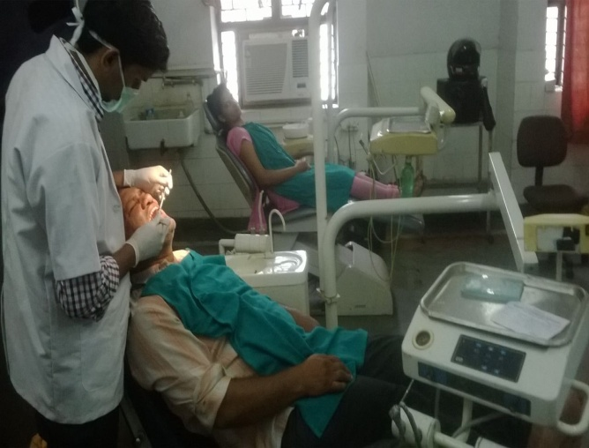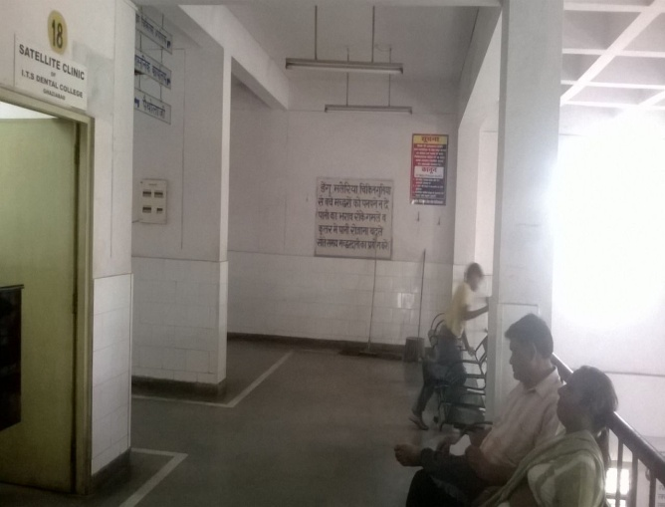

RAWLI SATELLITE CENTER
(TOTAL PATIENTS TREATED TILL DATE – 10,156)
Rawli Satellite center (started – 2013) is 16 km away from ITS Dental College. It is surrounded by more than 20 to 25 villages. It caters to the dental need of these villages. A dentist is posted daily from 8.30 am to 2.30 pm and all dental treatments are done free of cost. Only special cases of malignancy, orthodontic and prosthetic are referred to ITS Dental College for specialized treatment.
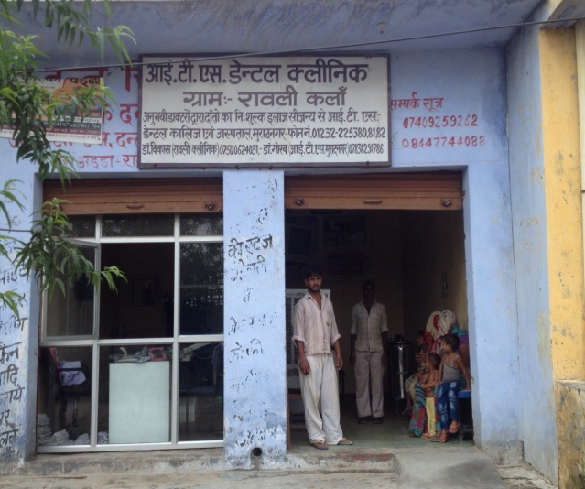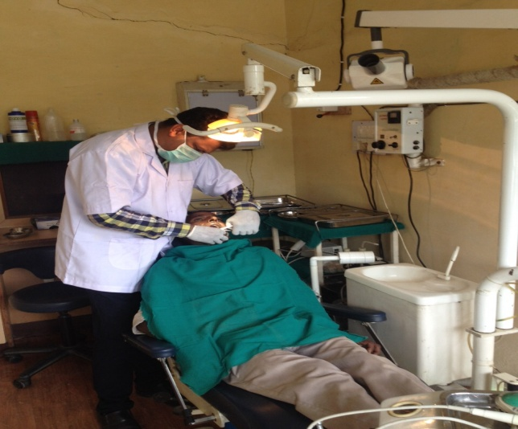
DASNA JAIL SATELLITE CENTER
(TOTAL PATIENTS TREATED TILL DATE – 10,497)
Dasna Jail Satellite Center (started - 2011) is 23 km away from ITS Dental College. All the jail inmates are screened and given dental treatments free of cost. All the dental materials are provided by the College andthe treatment provided to the inmates of the Jail is of the highest quality.
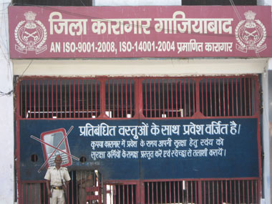

ITS MOHAN NAGAR SATELLITE CENTER
(TOTAL PATIENTS TREATED TILL DATE – 14,645)

ITS Mohan Nagar satellite (started – 2013) is located about 15 km from ITS Dental College. A dentist with 2 interns are posted in the satellite center. The timings of thecentre is from 9am to 3 pm and 5.00 pm to 7.30 pm. The satellite center is fully equipped with 3 fully functional dental chair and X-Ray unit. The satellite center provides good treatment at nominal charges. On an average the center treats 20 -30 patients’ on a daily basis.

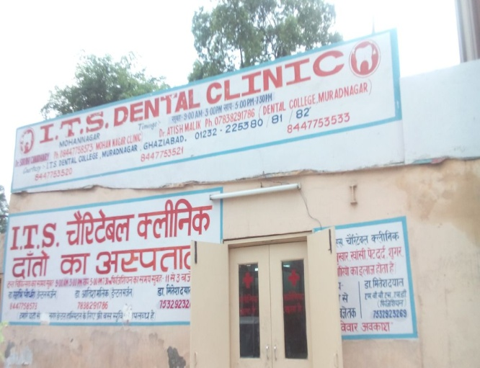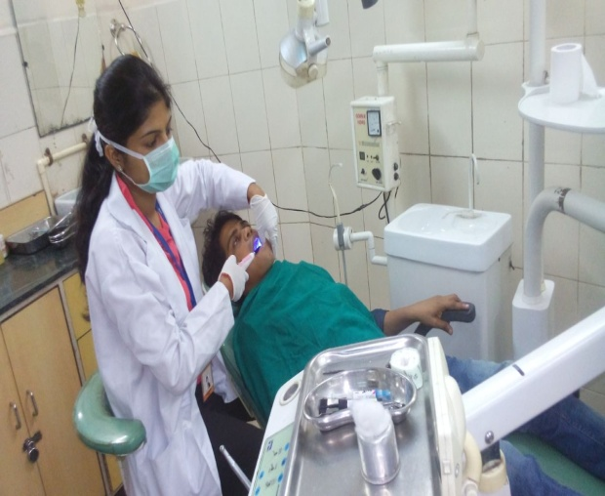
MMG
(TOTAL PATIENTS TREATED TILL DATE – 56,043)
MMG Satellite center (started – 2012) is situated near Ghantaghar in Ghaziabad. The centre is attached to MMG District Hospital, Ghaziabad and is 14 km away from ITS Dental College. A dentist and post graduate students specializing in various dentistry streams are posted in the satellite centers to treat a variety of cases. The timings of the satellite centers are 8am to 2pm. All treatments are done free of cost and patients encouraged to adopt sound oral healthpractises
.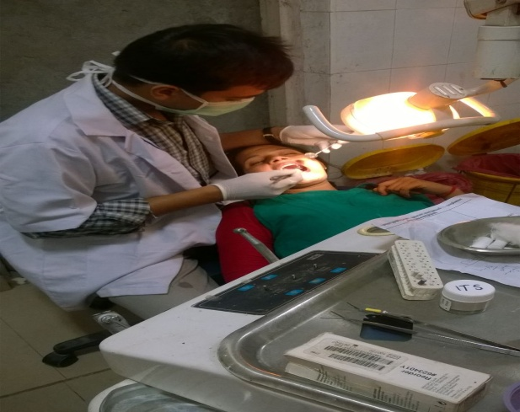 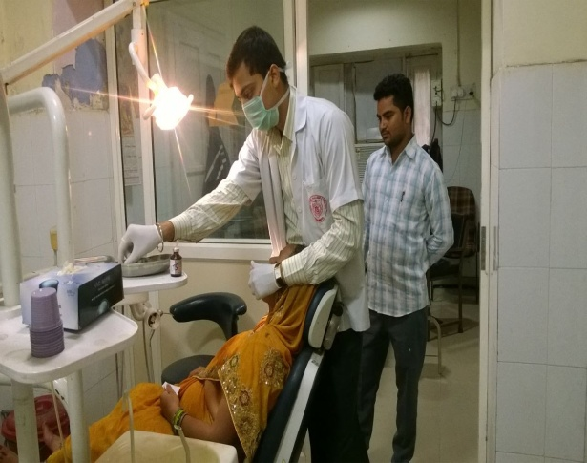

NANDGRAM
(TOTAL PATIENTS TREATED TILL DATE – 18,718)
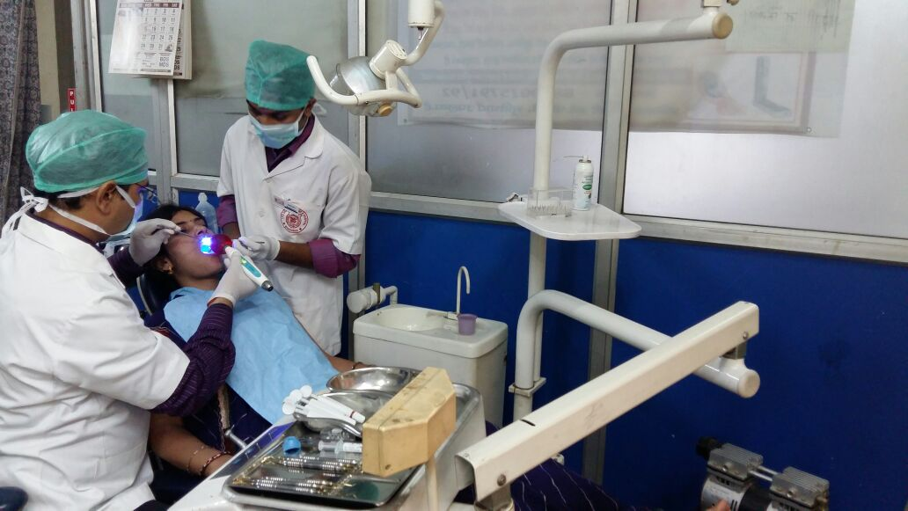
Nandgram satellite (started – 2013) is situated around 12 km away from ITS Dental College. It is surrounded by highly populated villages like Arthala and Pasonda. A qualified dentist along with some interns are posted in the satellite. The timings of the satellite clinic are from 8.30 am to 1pm and 4.00 pm to 8.00 pm. Satellite center is fully equipped with 3 fully functional dental chair and X-Ray unit. The satellite center provides good treatment at nominal charges.


